Motown by Night Primer
Chronicle: “Smuggler’s Blues”
Game Setting:
Detroit is a major port city on the Detroit River, in the Midwest region of the United States. Located north of Windsor, Ontario, Detroit is the only major U.S. city that looks south to Canada. It was founded in 1701 by the Frenchman Antoine de la Mothe Cadillac. It is known as the world's traditional automotive center — "Detroit" is a metonym for the American automobile industry — and an important source of popular music, legacies celebrated by the city's two familiar nicknames, The Motor City and Motown.^{[7][8]} Other nicknames emerged in the twentieth century, including Rock City, Arsenal of Democracy (during World War II),^{[9]} The D, D-Town, Hockeytown, and The 3-1-3 (its telephone area code).^{[10]} In recent years the city has become more "a symbol of US economic woes." The Detroit-Windsor area, a critical commercial link straddling the Canada-U.S. border, has a total population of about 5,700,000. In 1980, Detroit hosted the Republican National Convention which nominated Ronald Reagan to a successful bid for President of the United States. By then, nearly three decades of crime, drug addiction, and inadequate policies had caused areas like the Elmhurst block to decay.^{[27]} During the 1980s, abandoned structures were demolished to reduce havens for drug dealers with sizable tracts of land reverted to a form of urban prairie.
In the 1990s, the city began to enjoy a revival, much of it centered downtown. Comerica Tower at Detroit Center (1993) arose on the city skyline. In the ensuing years, under new leadership, three casinos opened in Detroit: MGM Grand Detroit and Motor City Casino, which have now added permanent resorts and Greektown Casino which is scheduled to open its permanent resort at the end of 2009 . New downtown stadiums were constructed for the Detroit Tigers and Detroit Lions in 2000 and 2002, respectively; this put the Lions' home stadium in the city proper for the first time since 1974. The city hosted the 2005 MLB All-Star Game, 2006 Super Bowl XL, 2006 World Series and WrestleMania 23 in 2007, all which prompted many improvements to the downtown area. The city's riverfront is the focus of much development; in 2007, the first portions of the Detroit River Walk were laid, including miles of parks and fountains. This new urban development in Detroit is a mainstay in the city's earnest desire to reinvent its economic identity through tourism.^{[30]} Along the river, upscale million dollar condos are going up, such as Watermark Detroit, some of the most expensive the city has ever seen. Some city limit signs, particularly on the Dearborn border say "Welcome to Detroit, The Renaissance City Founded 1701."
The city had the sixth highest number of violent crimes among the twenty-five largest cities in 2006. For the 2000 Census, median household income in the city was $29,526, and the median income for a family was $33,85326.1% of the population and 21.7% of families were below the poverty line. The Detroit suburbs in Oakland County, Macomb County, and northeastern and northwestern Wayne County are predominantly white. Of the African-Americans who live in the metropolitan area, about 70% live within the Detroit city limits. Metro Detroit's ethnic communities are diverse and include descendants of the French founders, as well as Irish, Germans, Scots, Poles, Italians, Greeks, Serbians, Turks, Armenians, Jews, Arabs, and Lebanese who settled during the city's early twentieth century industrial boom. Metro Detroit has the largest concentration of Belgians outside of Belgium;^{[92]} Cadieux Street on the city's east side north of Grosse Pointe constituted the heart of one of the few distinctly Belgian neighborhoods in the U.S. during the early- and mid-twentieth century. Dearborn has a sizable concentration of Arab Americans.
Game background:
The first camarilla presence in Detroit was established in 1765 as the population of the town grew to be the largest city between Montreal and New Orleans. Detroit’s kindred politics have been tumultuous from within as well as from threats without. Once the area was urbanized and large automotive manufacturing, steel milling, and international air and sea shipping turned the area into a metropolitan locale and transportation hub, the lingering garou tribes were all but gone save for a handful of urban dwelling Glasswalkers and Bone Gnawers. In the early 1950’s an influential and wealthy Nosferatu of some historical significance ascended to the throne after the bloody demise of her toreador predecessor. Rumors persist that Selma, the repugnant; prince of nearby Cleveland had a hand in dispatching with the sitting toreador prince as part of her long standing enmity with the clan of the rose. Detroit’s mage population is one of the highest in any city in the United States. There is an established cabal of mages of different traditions and their influence rivals (if not surpasses) that of the resident Kindred. Detroit’s current court is on good terms with both of its closest neighbors, Chicago and Cleveland. Detroit is a city in constant conflict with the Sabbat presence in nearby Canada. Rumors of threats to the city’s stability (mundane, mystical, and mythical) abound. The eternal jyhad slashes and burns away ones sanity, humanity, and very being like a wildfire in these tumultuous nights and alliances ebb and flow like the murky waters of Lake Erie. Only three things are certain about the kindred climate of Rock City these days, tensions are high, danger lurks around every corner, and someone or something is in the shadows pulling the strings and cackling while the puppets dance!

Some things to consider when crafting your character:
- Standard character creation rules but with a total of 20 freebies instead of 15
- All character regardless of age know they are kindred and how to use their blood abilities and the disciplines that THEY THEMSELVES possess. To know more, Kindred lore must be purchased at character creation. Characters may spend blood to make their skin warm and flush, make their heart beat for a scene; however, it is assumed that the characters that do not purchase masquerade as an ability at character creation forget to do these things as a default. A character’s age and humanity may also make even these masquerade reinforcing actions difficult to effectively pull off.
- All characters begin the game with $1000.00 in their pocket in addition to or in spite of any resources they purchase at character creation. Additionally each character may start with 1 firearm, 1 bladed weapon, one vehicle, and one “container” holding 5 points of vitae. All other items are at the storyteller’s discretion and must be ON THE CHARACTER SHEET! No assumptions will be made especially in regards to “gear carried.”
- All of the characters are new to Detroit (lived there less than 3 days) and all have no status in their current domain (those that purchased status must lobby the prince to have it recognized), but do know the location of the main Elysium. Any character starting with a cellular phone also has the number of their sire, their retainers, contacts, allies, the main Elysium receptionist, and the current password, “pimpernel.“
- Purchasing “city secrets” as knowledge will assist you in specific rumors and information about the area and each dot taking in city secrets OR masquerade will allow your character to know an additional kindred or supernatural inhabitant of the city.
Game mechanics house rules:
- Round = 5 seconds; scene = 10 minutes or 60 rounds (no it doesn’t exactly add up, but that’s the way it is gonna be, bitch!)
- Increasing stats: Expending one blood point will increase one physical attribute to its generational maximum for one scene or 10 minutes of “in game” time. Stats may be increased beyond generational limits by up to two points for one scene at the cost of one blood point per point increased.
- Feeding: characters may roll their unmodified stamina to determine how much blood they can ingest per round
- Healing: Characters may spend one blood point to heal one level of bashing/lethal damage. Healing wounds out of combat is automatic; however, healing wounds during combat or other highly active situations will require a successful stamina roll difficulty 6. Characters must spend 5 blood points and rest for 24 hours to heal each aggravated wound level. Characters must spend 5 blood points and a willpower in order to attempt to heal an aggravated wound in combat (or during non restful activity) and then must roll their stamina difficulty 5 and score at least 3 successes to be successful.
- Initiative: The character with the highest celerity score acts first in the round. Initiative is rolled for ties and all others without celerity. (wits + dex diff 6). The character with the lowest initiative score announces their action first and other characters announce their actions in order progressing to the character with the highest celerity. Once a character announces their actions, they may not be changed. This is to allow those with the highest initiatives/celerity the chance to chose their actions based on the actions of slower characters.
- Resisting: Resisting the use of dominate and presence (unless noted otherwise in the rules) is done by the expenditure of one point of willpower and successfully rolling willpower at the same difficulty of the acting character’s difficulty and scoring at least one success more than the acting character.
- Combat: It is assumed unless stated by the character that one will attempt to dodge or otherwise protect oneself when being attacked. For this reason attackers will always roll to hit a target by using their dex + appropriate skill vs. a difficulty of the target’s dex + dodge(when the target is aware of the attack). Characters may attempt to dodge as a main action in which case the dodging character will roll their dex + dodge (diff 7) as a contested roll against the attacker’s roll (diff target’s dex+ dodge). This dodge can only be used to dodge a single attack made against the target.
- Difficulties greater than 10 and excessive successes. For a difficulty of 10 that a character must score at least 3 successes on then two 10’s must be rolled. This roll also is a success for any roll of difficulty 11. Thusly for each two degree of difficulty in excess of 10, then an additional 10 must be rolled in the die pool. E.g. To hit a character with a dex + dodge of 16, then an attacker must roll four 10’s on their attack. For successful rolls over 6 successes the degree of accomplishment MAY be increased. When rolling to hit a target with a melee or ranged attack, every 3 successes over 6 adds an additional die to the attacker’s damage roll. One’s do not count against a character’s damage roll i.e. you can’t “botch” damage.
- Rituals, and other misc. Rituals take ten minutes per level of the ritual to complete unless otherwise noted in the description. Pavis of the foul presence, the blasé merit, is only effective on levels of presence up to level five. These and other such means of resistance have diminishing returns and benefits as the power that they are meant to foil increases.

Camarilla
 | 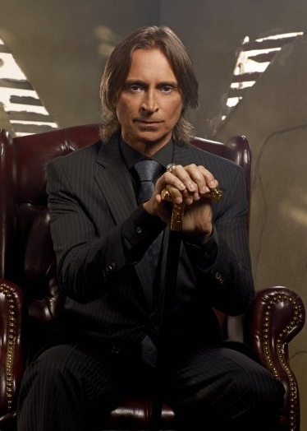
Prince: Margaret “Pretty Peggy” Shippen (2nd wife of Benedict Arnold). 6th generation Nosferatu (childe of Sheldon lord of the clog, childe of Harrod (Nosferatu inner circle)  - Influence major: shipping, law enforcement, media, politics.  - Influence minor: street crime, manufacturing, high society.  - Ani – 5, obf-6, pote-6, fort 5, aspx 3, clrty 3, prot-3, pres 1, dom 3. | Seneschal: Max Orenthall 7th generation Brujah. Influence major: organized crime, transportation. Minor: manufacturing, tourism  Pres – 5, Pot – 5, Clrty – 5, Aspx - 1, Dom – 3, Fort - 3

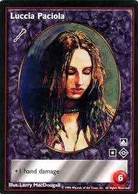 | 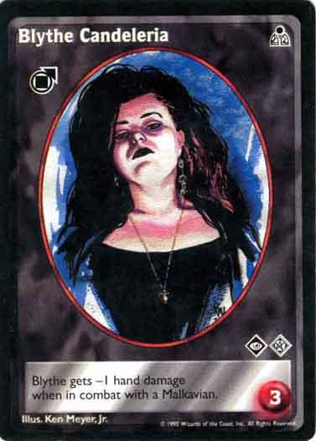 | 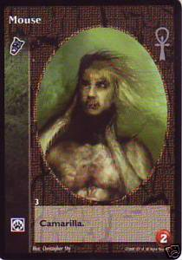 | 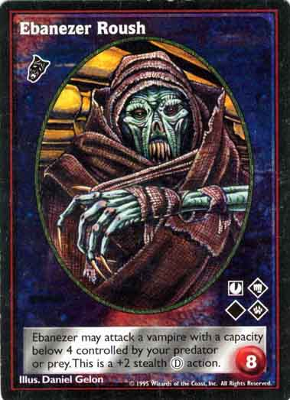
Sherriff:  Luccia Pacciola  8th gen Ventrue. DOM,fort, pres | Deputy 1.  Blythe Candeleria  10th gen Tremere. AUS, THAU | Deputy 2.  Mouse  11th Nosferatu. OBF ani pot CEL | Scourge:  Ebanezer Roush  8th gen Nosferatu.  adept at striking at very young kindred.

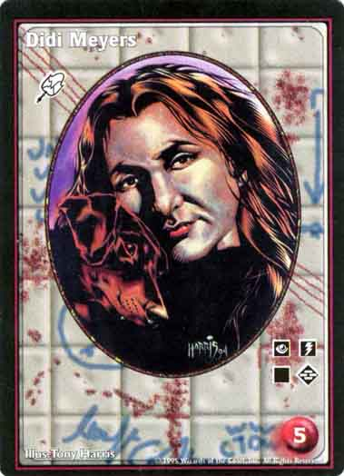 | 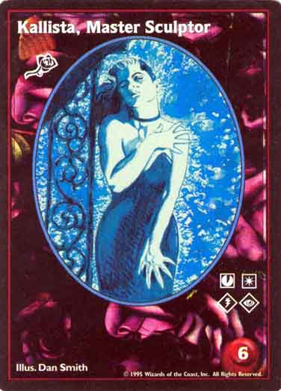
Keeper of Elysium: Didi Meyers 9th malk au ce DO ob | Chief Harpy: Kallista, Master Sculpter 10th Tore AU CE ps pt

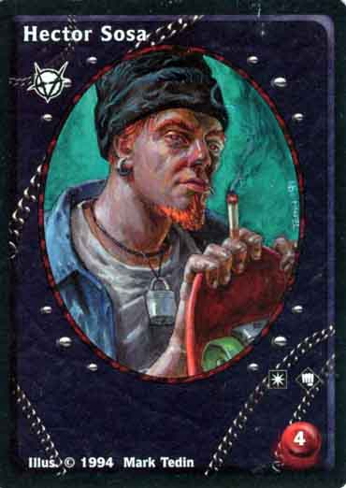 | 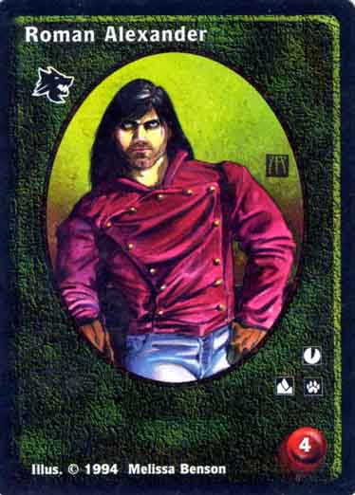 | 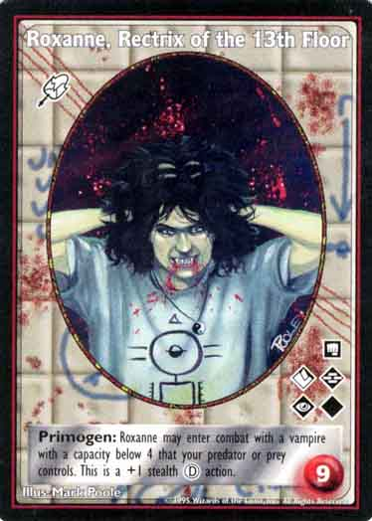 | 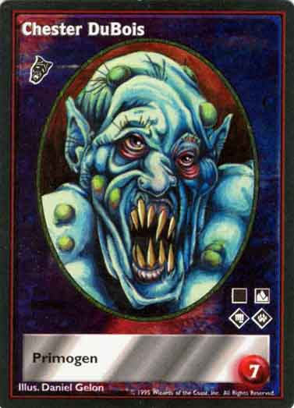
Hector Sosa 10th PO ps, | Roman Alexander 10th an fo pt, | Roxanne, Rectrix of the 13th Floor 7th AU DO FO OB po | Chester DuBois 9th AN fo ob PO,

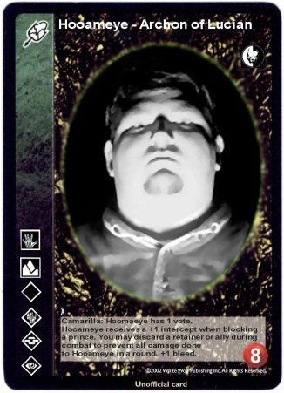 | 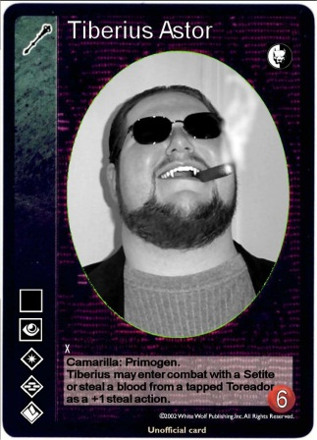 | 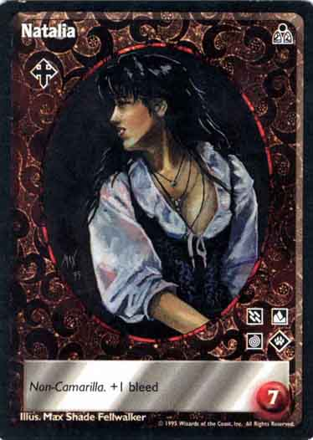 | 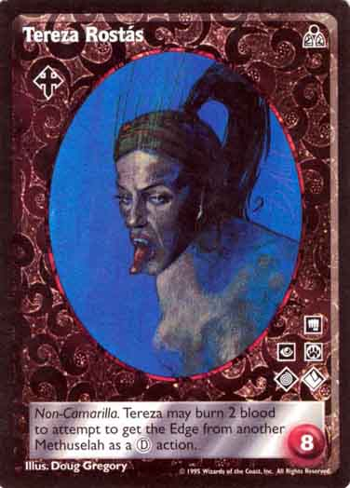
Hooameye 8th | –, Tiberius Astor 9th PRE DOM FORT obf aus | Natalia 8th

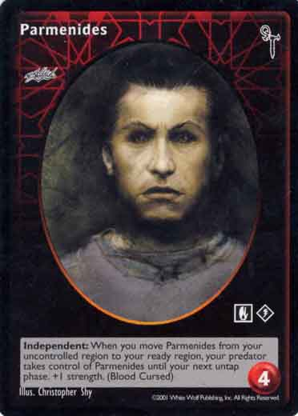 | 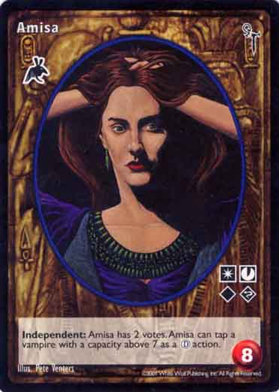 | 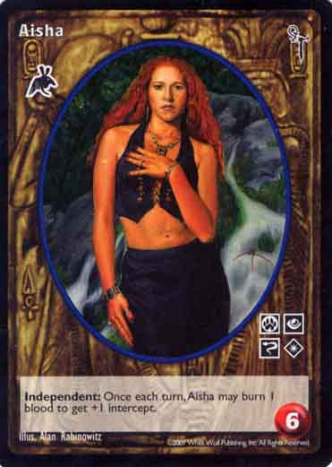
Parmenides 10th | Amisa, | Aisha

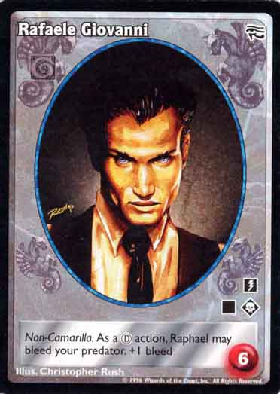 | 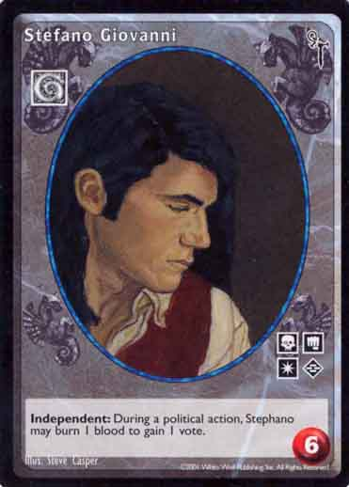 | 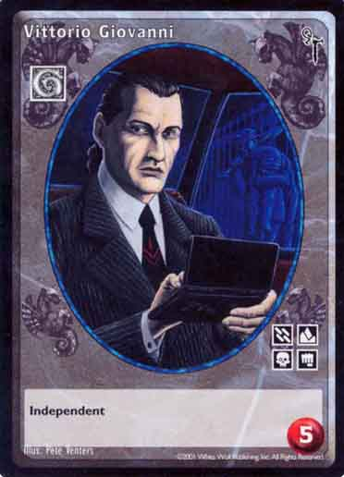 | 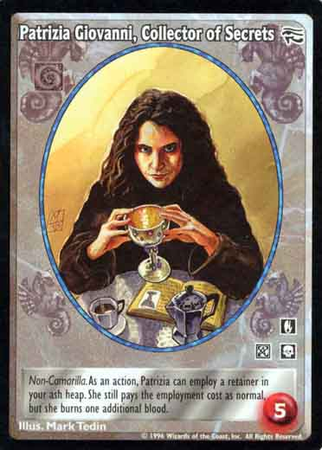
Rafael Giovanni 8th (necromancer/boss) | Stefano Giovanni 9th (politico) | Vittorio Giovanni 10th (mob capo) | Patrizia Giovanni, Collector of Secrets 10th (necromancer)

Other kindred by clan:
Brujah – Hilton Valentine 11th Gen Musician. (CODAY)
Kumiko Menendez 8th gen ball breaking bitch/CEO (JULIE) LEIGH’S CHARACTER ,
Gangrel – Riley Schaudenfreud 8th gen Socialite (KAITLYN)
Lasombra Antitribu -
Malkavian –, Dr. Abide Thornton 8th gen Occult Writer (Thrall- Poojah) (CHAD)
Nosferatu – Poojah 12th gen (thrall of Abide Thornton)
Toreador –, Corrin Bailey 8th gen waitress(MALLORY)
LAUREN
Tremere – Borgstrom Von Adelsvyard, Willhelm Mclaughlin 9th gen Librarian (KLINT)
Ventrue, Israel Steadman 12th Gen Mob Capo, (HARTFIELD’),
Niccolo Murry (1oth gen silver fang abomination)
Independants
Assamite:
Giovanni:
Ravnos:,
Settite:
Available influence | Elysiums and other institutions | Tourist spots | Universities/social centers
Academic  Transportation  Law  Politics  Health  Civic services  Religion  Media  High society  Occult  Street crime  Organized crime  Tourism  Manufacturing  Service industry | Palmer Park  Detroit Opera House  Detroit Institute of Arts.  Vitae Bars/hang outs:  Ruby Vial  The Thorny Rose  Bitter Tears  Newspapers:  The Detroit Free Press  The Detroit News | Detroit Institute of Arts  The Detroit Historical Museum  Charles H. Wright Museum of African American History  The Detroit Science Center  Detroit Public Library  Motown Historical Museum  Tuskegee Airmen Museum,  Fort Wayne  Museum of Contemporary Art Detroit  Detroit Electronic Music Festival  Detroit International Jazz Festival  NBA's Detroit Pistons  WNBA's Detroit Shock  Detroit Red Wings | - Wayne State University, a national research university with medical and law schools in the Midtown area  - University of Detroit Mercy with its schools of Law and Dentistry  - The College for Creative Studies  - Lewis College of Business,  - Marygrove College  - Wayne County Community College  - The Detroit College of Law  Hospitals:  Detroit Medical Center Henry Ford Health System, St. John Health System, John D. Dingell VA Medical Center

Sabbat
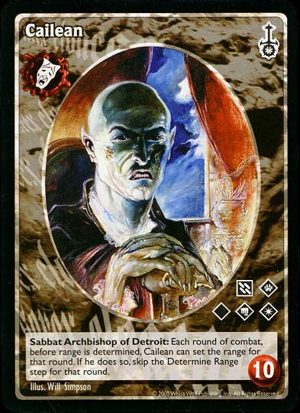 | 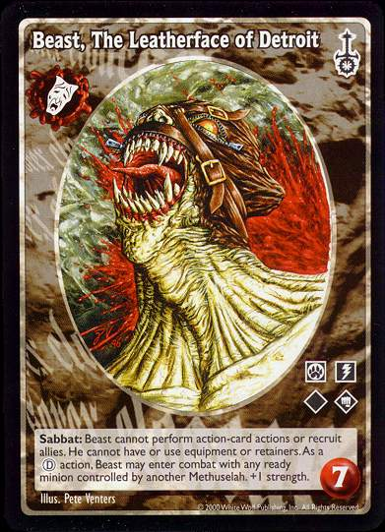 | 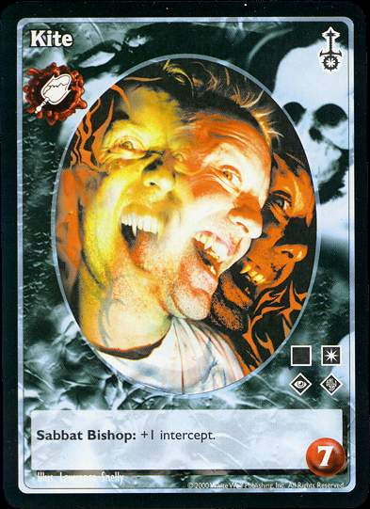 | 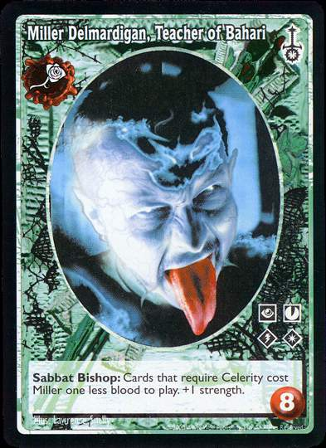
Archbishop: Cailean 6th nos-anti ANI OBF POT PRE dom | Bishop: Beast, The Leatherface of Detroit Nos-anti 8th OBF POT ani cel | Bishop: Kite 9th Malk-anti (+1 intercept) | Bishop: Miller Delmardigan, Teacher of Bahari 8th Tor-anti CEL PRE aus pro - +1 str.

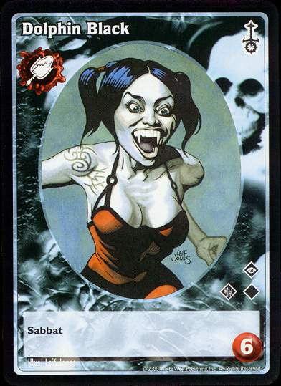 | 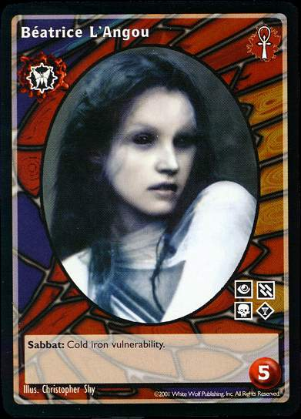 | 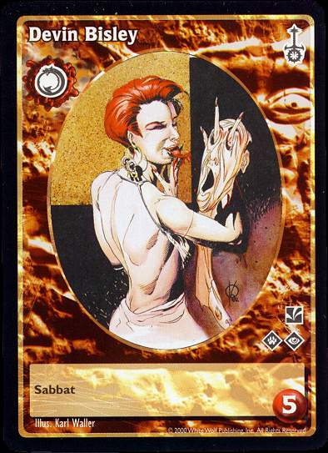 | 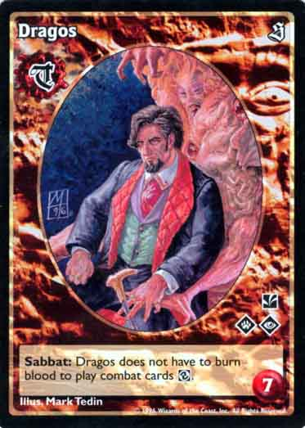
Pack Leader: Dolphin Black 9th Malk-anti | Pack priest: Béatrice L'Angou Kyasid 11th aus dom nec MYT | Devin Bisely 10th gen, | Dragos 8th
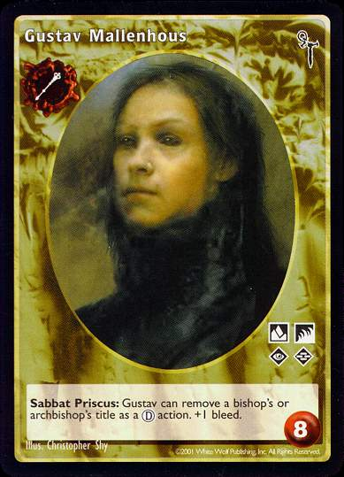 | 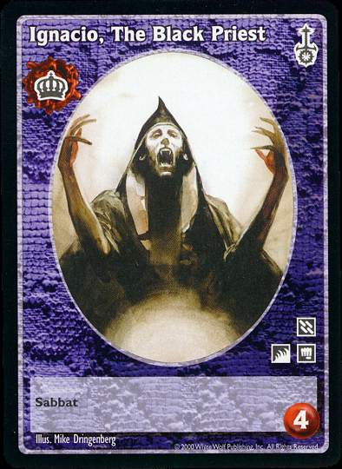 | 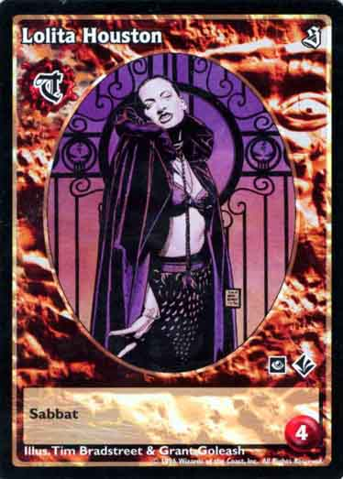 | 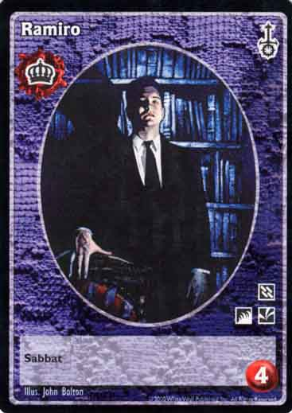
Pack Leader: Gustav Mallenhous 8th Ven-anti | Pack priest: Ignacio, The Black Priest lasombra 11th | Lolita Houston 11th, | Ramiro

Garou
1. - Dr. Stephen Garrison Rank 4 Gasswalker
2. - Shakey Mac Rank 3 Bone gnawer
3. - Susan Anthony Rank 3 Black Fury
Mages
1. Sarah Milstead Unitarian Minister – w/true faith 3 - Celestial Chorus
2. Arthur Finklestein – Catholic priest/Choir director - Celestial Chorus
3. Martin Picard – Star Trek Geek - Sons of Ether
4. Travis Foster aka “Darth Malleus” - Sons of Ether
5. Ms. Shen Te – Professor of Asian studies and Eastern Religion Marygrove College - Akasic Brotherhood
6. Sensei Phillip Nagatanata – Head of the Perfect balance Dojo. Black belts in Aikido, Judo, Jujitsu, Karate, Kendo - Akashic Brotherhood
7. Angelina San Marco – “dividebyxero” – Computer programmer/hacker, network admin for The Detroit Science Center Virtual Adepts
8. Mary Ellen Hazelhurst “moondaisey” Pagain priestess and practicing witch -Verbena
9. Dr. Isaiah Menklestien “Dr. Detroit” Professor of pharmacology, toxicology, and chemistry Wayne St. U. - Cult of Ecstacy
10. Thadius Zho – Professional fuck yo shit up mage / Friend of House and Clan Tremere - Order of Hermes

Rumors, Plot Hooks, Story ideas, challenges, and intrigues
Leatherface out of torpor after 15 years. Numerous vicissitude doubles running around to scare the cammies
Haves vs. the Have-nots. The pillar clans struggle for dominance and control over the nos-malk-brujah death grip on the city
Elders participating in a smuggling ring to take neonate vampires and sell them as food or diablerie fodder
Investigation of the secret mage’s cabal known as the Brotherhood of Inspired enlightenment
The prince trying to acquire a painting of her late husband from Jan Pieterzoon
The Prince having her portrait taken

